BAHRIA UNIVERSITY (KARACHI CAMPUS)
Department of Software Engineering.
Assignment 03 (Fall 2022)

Course Title: Applied Physics Course Code: GSC-114
Class: BSE 1B Shift: Morning
Course Instructor: Engr. Rizwan Fazal Date: 04 Jan 2023
Submission: 15 Jan 2023 Max Marks: 10 Points

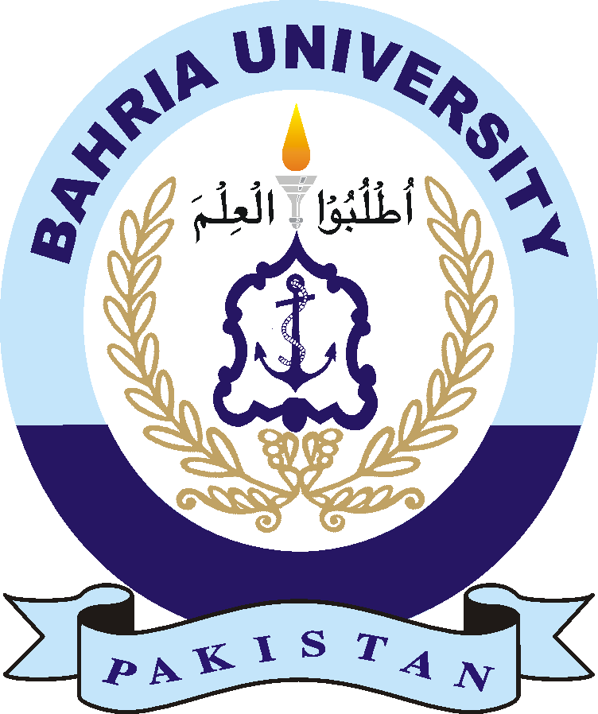

Abdullah
02-131222-099
1 B
Submitted By:

Name: _________________________________
Registration Number: _____________________
Section: ________________________________
Assignment No 03

